**Digital Music Store Data Analysis Dashboard Report**

**Problem Statement**

The digital music store wants to better understand its sales performance, customer distribution, and product popularity. Although transaction data is available, there is a lack of clarity on which genres, tracks, formats, and regions are contributing most to revenue.

**Objective**

To analyze and visualize music store data to:

* Identify top-selling genres and tracks.
* Understand revenue trends over time.
* Evaluate customer distribution by country.
* Assess the popularity of media formats.
* Provide insights to support sales and marketing strategies.

**Requirement Analysis**

**Data Inputs Required:**

* Customer details (ID, country, city)
* Invoice and invoice line data (unit price, quantity, date)
* Track metadata (track ID, name, album ID, genre ID, media type)
* Genre and artist information

**Tools Used:**

* Power BI: for dashboard creation and interactive visualization
* Excel: for data preparation and validation
* SQL or Python: for advanced data transformation

**KPIs Visualized:**

* Total Revenue: 4709.43
* Top 10 Genres by Sales
* Top 10 Selling Tracks by Quantity
* Monthly Revenue Trend (by year and month)
* Media Type Usage (pie chart)
* Number of Customers by Country
* Filters for city and month selection

**Key Insights & Recommendations**

1. **Top-Selling Genre**:
   * Rock is the leading genre in terms of revenue.
   * Recommendation: Focus marketing campaigns and playlists on Rock music.
2. **Top Tracks**:
   * "War Pigs" is the highest-selling track.
   * Recommendation: Feature top tracks in promotional banners and curated lists.
3. **Media Format Usage**:
   * MPEG Audio Files dominate usage (~87%).
   * Recommendation: Continue supporting and promoting MPEG format.
4. **Customer Distribution**:
   * The USA has the highest number of customers, followed by Canada and Brazil.
   * Recommendation: Allocate more advertising and artist engagement budget to these countries.
5. **Monthly Revenue Trends**:
   * Revenue fluctuates but shows overall stability with occasional peaks.
   * Recommendation: Investigate dips and spikes to optimize promotions and release schedules.

**Result**

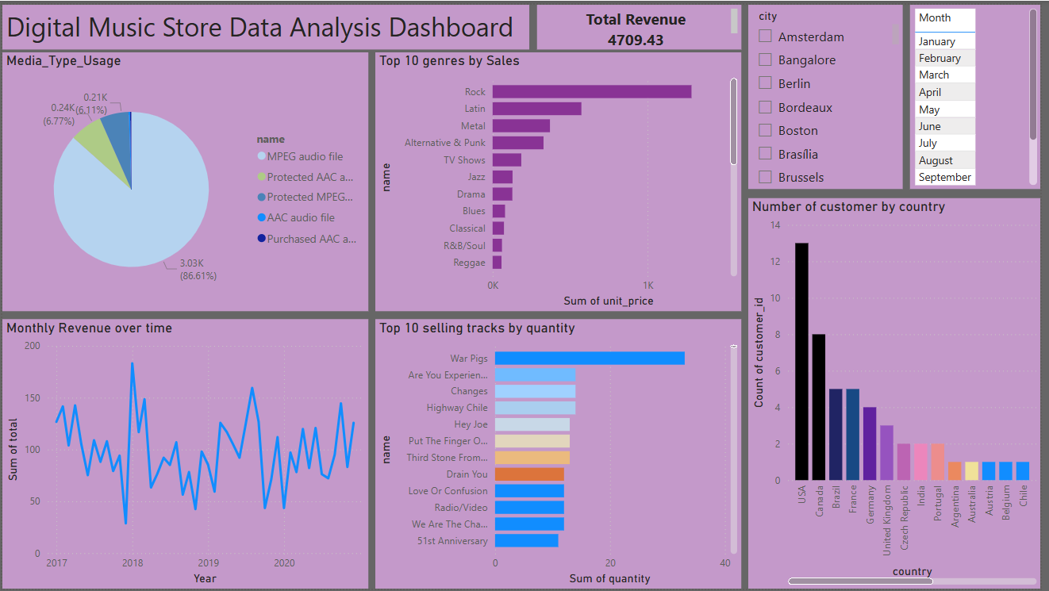

**Conclusion**

The dashboard provides a visual and data-driven view of the music store's performance. With insights into genres, tracks, formats, and geography, stakeholders can make better decisions on product focus, regional marketing, and content planning. Regular updates to this dashboard will ensure continuous performance monitoring and strategic improvements.